Seat No:_________________ | Enrolment No:__________________
LOK JAGRUTI KENDRA UNIVERSITY
MCA Semester – 1 Remedial Examination Summer 2025

Subject Code: 40110201/140110201 | Date: 25/06/2025
Subject Name: Data Structures
Duration: 02:30 Hours | Total Marks: 50
Instructions:
1. Attempt all the questions
2. Figures on the right indicate the marks.
3. Draw the figures and give suitable examples as and where necessary.

Q - 1 | Answer The Following Questions.
 | Define: Primitive data structure | 1
 | What is Algorithm? | 1
 | Define: Asymptotic Notations | 1
 | Differentiate between Liner and Non Liner data structures. | 3
 | Explain the classification of data structures with example. | 4
 | OR
5. | Explain Time Complexity of an algorithm with example. | 4
Q - 2 | Answer The Following Questions.
 | Given the base address of an array A[1100 ………… 1700] as 1080 and the size of each element is 1 bytes in the memory, find the address of A[1400]. | 1
 | State True or False: Queue is a FIFO data structure | 1
 | Differentiate between peek() and pop() functions of Stack. | 1
 | Convert Infix expression into Postfix expression using Stack:  (A + B / C * (D + E) – F ) | 3
 | Define: Singly Linked list. List out types of Linked List and write an algorithm to insert an element at the first position in the Singly Linked List. | 4
 | OR
10. | Define: Queue. List types of Queue. Write an algorithm for Enqueue operation on Simple Queue. | 4
Q - 3 | Answer The Following Questions.
 | Define : Root Note | 1
 | What is Weighted Graph? | 1
 | Find the Adjacency Matrix of the following graph:  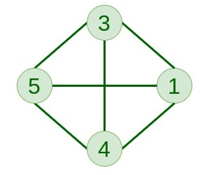 | 1
 | Draw expression tree of given expression : a + b * (c – d) | 3
 | Construct a Binary Search Tree from the following data and find In-order, Pre-order, and Post-order traversal:  10,12,5,4,20,8,7,15 and 13. | 4
 | OR
15. | Consider the graph given below. Find the Minimum Spanning Tree of this graph using Kruskal’s algorithm.  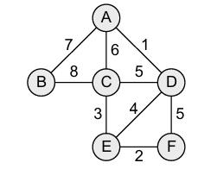 | 4
Q - 4 | Answer The Following Questions.
 | Define: Hash Table | 1
 | What is Minimum Spanning Tree? | 1
 | What is the Time Complexity of Bubble sort algorithm? | 1
 | Define Collision. Explain any two techniques for Collision resolution with suitable example. | 3
 | Sort following data using Radix sort. (show every step) | 4
 | OR
20. | Sort following data using Shell sort. (show every step)  23,29,15,19,31,7,9,5,2 | 4
Q - 5 | Answer The Following Questions.
 | What is the advantage of Circular Queue over Simple Queue? | 1
 | Find out the degree of each node for following graph.  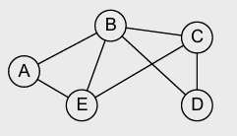 | 1
 | Delete node 25 from the following tree and draw resultant tree.  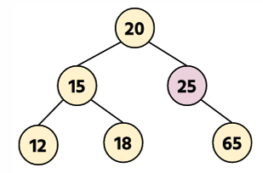 | 1
 | List and explain types of rotations used in AVL tree with its example. | 3
 | Find BFS and DFS Traversal of the following graph. Consider A as the starting vertex.  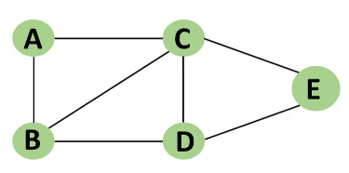 | 4
 | OR
25. | Apply Dijikstra‘s algorithm to find shortest path on following graph with node A as the starting node.  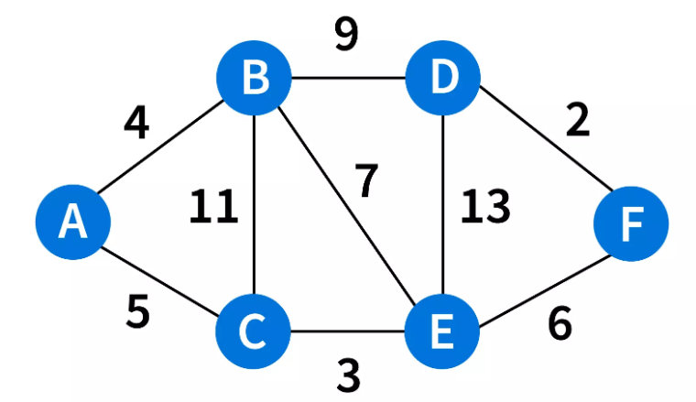 | 4

******************************************************************************************************************

